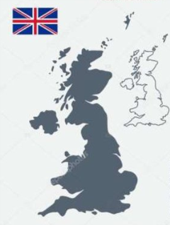 | THE STRUCTURE OF GOVERNMENT IN GREAT BRITAIN
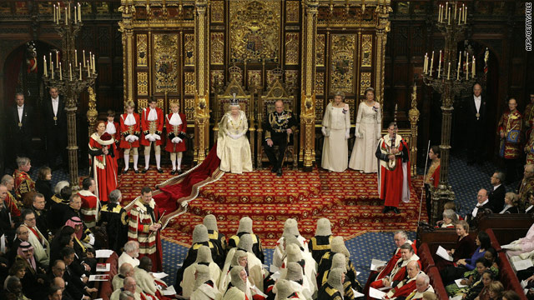
The Queen is officially head of all the branches of government, but she has little direct power in the country. The constitution has three branches: Parliament, which makes lows, the government, which "executes" laws (puts them into effect) and the courts, which interpret laws. Parliament has two parts: the House of Commons and the House of Lords. Members of the House of Commons are elected by the voters of 650constituencies. They are known as Members of Parliament. The Prime Minister is advised by a Cabinet of about twenty other ministers.
The Prime Minister, or leader of the Government, is usually the leader of the political party. The Cabinet includes the ministers in charge of major government departments or ministries. Departments and ministries are run by civil servants, who are permanent officials. Even if the Government changes after an election, the same civil servants are employed. Members of the House of Lords are not elected. About 70 per cent of them are "hereditary peers" because their fathers were peers before them. The 30 per cent are officially appointed by the Queen, on the advice of the Government, for various services for people.

VOCABULARY:
to execute - исполнять
to interpret - толковать
hereditary - наследственный

QUESTIONS:
1. Who is the head of government in Britain?
2. How many parts does Parliament have? What are they?
3. Who is the leader of political party?
4. What can you tell about the House of Lords?

