DIFFERENT TYPES OF HOBBIES

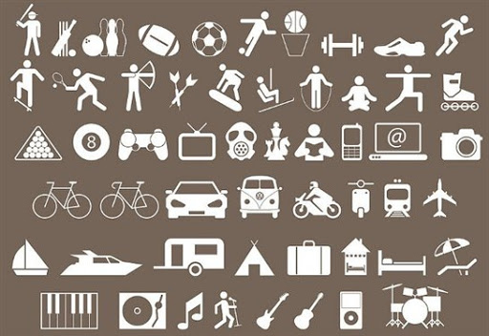

Письменно ответьте на вопросы и запишите перевод своих ответов:
- How do you think, what is the most popular hobby nowadays?
- What is your favorite hobby? Why?
- Fishing is one of the oldest men’s hobbies, isn't it?
- Do you like fishing?
- Who likes to play different computer games?
- Do you like to play computer games?
- Does President Bill Clinton play saxophone or piano?
- Do hobbies differ like tastes?

