My Future Specialty
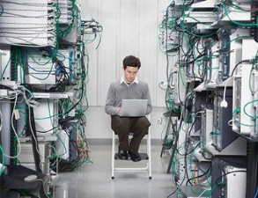 | I study at the industrial and economic college¹ in Spassk- Dalny. My future specialty is connected with² computers. In the nearest future I am going to be a system administrator³. The system administrator belongs to the category of specialists⁴.
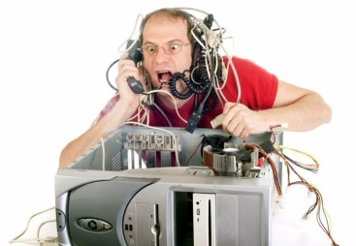 | The system administrator must know the basics of local networks⁵ (network equipment⁶, principles of building local area networks⁷), technical characteristics⁸, operation modes⁹, rules for technical operation of equipment¹⁰ of local area networks, office equipment¹¹, servers and personal computers¹².
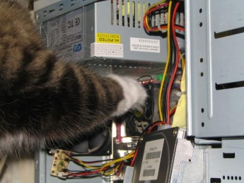 | The system administrator should also know hardware and software¹³ of local area networks, languages and programming methods¹⁴.  A good system administrator knows the basics of information security¹⁵, ways to protect information¹⁶ from unauthorized access¹⁷, damage or intentional distortion¹⁸.
Besides the system administrator has to know how to draw up¹⁹ all the technical documentation²⁰.
In future the system administrator can do excellent career²¹ and become the head of the IT department²².

